



**EXCERPT FROM THE SUPPLY AND INSTALLATION SPECIFICATIONS MANUAL**

ZINTEK® TITANIUM ZINC AND APPLICATION DESIGNS





*ZINC-TITANIUM IN ARCHITECTURE*

EXCERPT FROM THE SUPPLY AND INSTALLATION SPECIFICATIONS MANUAL

zintek® titanium zinc and application designs

V EDITION



**INDEX**

**SUPPLY AND INSTALLATION SPECIFICATIONS**

Zintek® titanium zinc

Zintek®: general inconstruction Protection of the substructure

**PAG.**

pag. pag. pag.

**7**

7

7

8

**ITEMS OF THE MANUAL**

Roofing Walls Intradoses Gutters Accessories

**PART 1**

**PAG.**

pag. pag. pag. pag. pag.

**9**

9

12

14

15

18

**ITEMS OF THE MANUAL**

**PART 2**

**PAG.**

**19**

**COVERING SPECIFICS**

Technical notes zintek® roofing Application designs

**PAG.**

pag. pag.

**27**

28

33

**FAÇADE SPECIFICS**

Technical notes zintek® façade coverings Application designs

**PAG.**

pag. pag.

**43**

44

47



**SUPPLY AND INSTALLATION SPECIFICATIONS**

**ZINTEK® TITANIUM ZINC**

The Zintek ® Specifications Manual features many highly specific items. It is structured in two parts:

1. ) The first part concerns items most commonly and normally used by the designer as a general cost indication to define the works; these are often sufficient to define the specifications of completed works and their precise cost.
2. ) The second part concerns items which characterise single construction details within a single general section; these are generally not required by the designer, but are included in a manual for minor works or in cases requiring detailed design specifications and a number of single components within a complex structure. This list also allows the reader to extrapolate certain items and place them where they are needed in relation to their intended use.

Items from the Specifications Manual always refer to the “Sviluppo in Architettura” Manual for the design and installation of zintek® covering and cladding solutions.

The item “use of the pre-existing scaffolding” must be interpreted as a permit to use the pre-existing scaffolding for construction works in progress; otherwise, it must be calculated separately.

The preliminary assessment is based on the surfaces indicated on the design drawings. The final balance will be based on the real measurements following the conclusion of the works, on the basis of unit costs.

**ZINTEK®: GENERAL INCONSTRUCTION**

zintek® is the commercial name of the titanium zinc alloy compliant with European Standard EN 988. This Standard outlines requirements for flat zinc-copper-titanium alloy used in the construction industry. As stated in EN 1179, the alloy must be produced from Z1-quality zinc, i.e. containing at least 99.995% zinc, with the addition of alloying elements. The Standard EN 988 indicates the tolerated copper and titanium percentages: Cu 0.08 – 1%, Ti 0.06 – 0.2% plus primary EN 1779-certified Z1 zinc for the remaining part. Copper increases the material’s tensile strength; titanium increases its resistance to permanent deconstruction over the course of time; the combination of these two elements decreases the expansion coefficient of the alloy. The melting point of the alloy is equal to 420°C, its recrystallisation limit is > 300°C and its specific weight is 7.2 Kg/dm3. It is an anisotropic material with a longitudinal-direction expansion coefficient of 0.022 mm/m°C. Furthermore, the alloy is non-magnetic, non-combustible, easy to recycle and non-pollutant. The weight of the standard 7/10 mm laminate is 5 Kg/m².

7



SUPPLY AND INSTALLATION SPECIFICATIONS

**PROTECTION OF THE SUBSTRUCTURE**

Before installation of the zintek® titanium zinc, the substructure and wooden planking must be protected from adverse weather conditions by using specific waterproof sheathing sheets, so that the zintek® can be installed on dry planking. These protection sheets, which will be removed before installing the zinc covering, must be joined together via overlaps and sealing tape junctions. The sheets must be cut-free, and no parts of the covering must remain unsheathed, with the exception of already protected elements such as finished chimneys or other projecting parts.

8



**ITEMS OF THE MANUAL PART 1**

**ROOFING**

* 1. **Seam roof cladding**

Seam roof cladding: Supply and installation of zintek® titanium zinc roof cladding, compliant with Standard EN 988, 7/10 mm thickness, featuring a double seaming system, with pitch obtained from standard strips (e.g. 500 mm pitch from 570 mm development). Execution according to technical drawings. Also included are fixed, sliding (or large sliding) stainless steel anchor brackets, fixed with stainless steel screws.

Regulatory roofing references: UNI 10372 Wind assessment: EN 1991-1-4.

* + 1. zintek® natural
    2. zintek® pre-weathered rock grey
    3. zintek® the colored ones
  1. **Curved seam roof cladding (barrel)**

Crimped roof cladding: Supply and installation of zintek® titanium zinc roof cladding, compliant with Standard EN 988, 7/10 mm thickness, featuring a double seaming system, with pitch obtained from standard strips (e.g. 500 mm pitch from 570 mm development). Execution according to technical drawings. Also included are the fixed, sliding stainless steel anchor brackets, fixed with stainless steel screws.

Regulatory roofing references: UNI 10372 Wind assessment: EN 1991-1-4.

* + 1. zintek® natural
    2. zintek® pre-weathered rock grey
    3. zintek® the colored ones

**01.2 Seam roof cladding in conical plates**

Roof covering in conical plates: Supply and installation of zintek® zintek® titanium zinc roof cladding, compliant with Standard EN 988, 7/10 mm thickness, with a double seaming system of with conical plates, with distance of joints width from …… mm to …… mm. Execution according to technical drawings. Also included are the fixed, sliding stainless steel anchor brackets, fixed with stainless steel screws.

9

ITEMS OF THE MANUAL PART 1

Regulatory roofing references: UNI 10372 Wind assessment: EN 1991-1-4.

1. zintek® natural
2. zintek® pre-weathered rock grey
3. zintek® the colored ones
   1. **Seam roof cladding in conical barrel slabs plates (e.g. Dome)**

Dome covering in conical plates: Supply and installation of zintek® titanium zinc roof cladding, compliant with Standard EN 988, 7/10 mm thickness, with a double seaming system with conical cladding plates, with distance of joints width from …… mm to …… mm. Execution according to technical drawings. Also included are the fixed, sliding stainless steel anchor brackets, fixed with stainless steel screws.

Regulatory roofing references: UNI 10372 Wind assessment: EN 1991-1-4.

* + 1. zintek® natural
    2. zintek® pre-weathered rock grey
    3. zintek® the colored ones
  1. **Shingles roof**

Coating for shingle roof: Supply and installation of zintek® titanium zinc roof cladding, compliant with Standard EN 988, 7/10 mm thickness, with shingles in diamond, rectangular, square, or parallelogram shape (a minimum slope of 25° and minimum slope of 12°, with overlap of the edges to closed angles made by means of waterproof pockets), with dimensions obtained from a standard strip (< 600 mm width and < 3000 mm length). Execution according to technical drawings. Also included are the anchor tabs fixed with stainless steel screws.

Regulatory roofing references: UNI 10372 Wind assessment: EN 1991-1-4.

* + 1. zintek® natural
    2. zintek® pre-weathered rock grey
    3. zintek® the colored ones

10



* 1. **Stepped slat roof**

Stepped slat roof cladding: Cladding with zintek® titanium zinc slat system, thickness 8/10 mm, according to EN 988, with slat width 200 – 540 mm and length max. 5 m. Minimum slope of 12°. Zintek® titanium zinc slats will be fixed on special galvanised metal support brackets, fixed to the underlying substructure. This includes fixing materials with stainless steel screws.

Regulatory roofing references: UNI 10372 Wind assessment: EN 1991-1-4.

* + 1. zintek® natural
    2. zintek® pre-weathered rock grey
    3. zintek® the colored ones

**01.6 Ventilated roof substructure with seam crimped or shingle system**

Ventilated roofing substructure: supply and laying of planks made of dried raw fir wood < 18% min. thickness 23 mm, with width from 80 mm to 140 mm, and with interspaces of 5-9 mm, for the laying of zintek® titanium zinc. Strips of fir wood of xx x yy mm with ventilation function and support for the plank held in place with certified fixing screws.

Standard ref: UNI 10372 and UNI 11418-2.

**01.7 Supply and installation of insulation panel**

Supply and laying of insulation board (rock wool, wood fibre, polyurethane, etc.) of rigid / soft type and density

…… kg/m3, thickness ……, for ventilated roof (with wooden retaining slats interposed if necessary).

Included in the price are the Steam brake type USB Micro Riwega to be placed under the panel and the waterproof membrane with high breathability type USB Protector SILVER 230 Riwega in contact with the ventilation laid with strips and sealed fittings.

11

ITEMS OF THE MANUAL PART 1

**01.8 Supply and installation of 8 mm h separator layer laid on wooden planking**

Supply and installation of separator layer type Riwega USB drenlam light with height 8 mm, air mass 350 g/m2, resistant to temperatures between -40°C/ + 90°C, 100% virgin PP with carbon black non-recycled for greater durability over time, to be placed under the zintek® titanium zinc coating covering, with anti-noise function. It is necessary to install under the metal roofing up to a flap slope of 75°.

**01.9 Supply and installation of 14 mm h separator layer laid in combination with waterproof sheaths**

Supply and laying of a drainage filament mat separation layer type Riwega USB Drenlam Blutech with a height of 14 mm, mass per unit area of 450 g/m2, resistant to temperatures between -40°C/+90°C, 100% virgin PP with neutral master batch non-recycled for increased durability, with conformation of the bubbles for a better flow of water, high resistance to wear and to external loads such as snow and photovoltaic panels min. at 5kPa, to be placed under the zintek® titanium zinc covering, with anti-noise function. It is necessary to install under the metal roofing, up to a flap slope of 75°.

**WALLS**

* 1. **Metal seam wall cladding**

Metal seam wall cladding: Supply and installation of pre-weathered wall cladding with titanium zinc zintek®, compliant with Standard EN 988, 8/10 mm thickness, with angular seaming system, (e.g. 500 mm pitch from 570 mm development) or available in standard measurements. Execution according to drawing. Included in the price are expansion joints and stainless steel anchor brackets fixed with stainless steel screws. It also includes a perforated sheet for wall-based ventilation.

* + 1. zintek® pre-weathered rock grey
    2. zintek® the colored ones

**02.1a Wooden substructure for ventilated metal seam wall**

Wooden substructure for ventilated metal seam wall: supply and installation of vertical fir wood with a thickness of …… mm with ventilation function and supported by a beam. Base in dried raw fir wood of min thickness. 23 mm, laying of boards in dried raw fir wood < 18% min. thickness 23 mm, with width from 80 mm to 140 mm, and with interspaces of 5-9 mm, for laying the crimped zintek®.

12



Standard ref: UNI 10372 and UNI 11418-2.

**02.1b Metallic substructure for ventilated metal seam wall:**

Supply and installation of substructure made of aluminium or galvanised steel with pitch of about 1000 mm according to the technical verification, fixed to the wall with angle brackets, suitable to contain the insulation panel. Next orthogonal profile for ventilation on which to fix the wooden boards or the corrugated sheet of minimum thickness 0.6 mm for laying the crimped zintek®. All with rulers to adjust any out of sync. This includes suitable type-approved fastenings for facades.

**02.2 Supply and installation of wall insulation panel**

Supply and installation of wall insulation board (rock wool, wood fibre, polyurethane, etc.) with density of …… kg

/ m3 and thickness ……, for ventilated wall fixed to the wall with special fasteners.

* 1. **Interlocking slat wall**

Supply and installation of wall cladding with horizontal or vertical zintek® titanium zinc slats, according to EN 988, thickness 10/10 mm obtained from standard strips (e.g. with xx-yy mm pitch). Execution according to drawing. Fixing materials are included in the price. It also includes a perforated sheet for wall-based ventilation.

* + 1. zintek® pre-weathered rock grey
    2. zintek® the colored ones

**03.1 Ventilated wall substructure for slats**

Supply and installation of substructure in aluminium or galvanised steel, fixed to the rear structure, composed of angle brackets suitable to contain the possible insulation panel, and L or T profiles to support the slats and to create the ventilation space. This includes suitable fasteners and systems for adjusting any out of sync panels.

13



ITEMS OF THE MANUAL PART 1

**03.2 Supply and installation of wall insulation panel**

Supply and laying of insulation board (rock wool, wood fibre, polyurethane, etc.) with density of …… kg / m3 and thickness …… mm, for ventilated wall, anchored with special fasteners.

* 1. **Shingles wall**

Wall covering in shingles: supply and installation of wall covering in zintek® titanium zinc according to EN 988, thickness 8/10 mm, in rectangular shingles with horizontal/vertical orientation or in rhomboid shingles with a width of < 500 mm. Execution according to technical drawings. Also included are the anchor tabs fixed with stainless steel screws. Including perforated wall-based sheet metal.

* + 1. zintek® pre-weathered rock grey
    2. zintek® the colored ones

**05.0 Stepped slatted wall**

Wall cladding in step slats: supply and installation of cladding with zintek® titanium zinc step slats system, thickness 8/10 mm, according to EN 988, with slats width 200 - 540 mm with maximum length of 4 ml. Zintek® titanium zinc slats will be fixed on special galvanised metal support brackets, fixed to the underlying substructure. This includes fixing materials with stainless steel screws.

**INTRADOSES**

* 1. **Door or window sheeting**

Supply and installation of door or window (intrados) in zintek® titanium zinc compliant with Standard EN 988, thickness 8/10 mm (or 10/10 mm), supplied and installed. Execution according to drawing. The price includes: the support raw wood min. 23 mm thick planking, hooking strips, anchoring equipment, the three- dimensional separation layer from the support, construction of the drip edge, the internal vertical fold and lateral folds, the construction of waterproof corner connections, the perforated sheet for the ventilation inlet/ outlet where necessary, the off-cut wastage:

* + 1. zintek® pre-weathered rock grey
    2. zintek® the colored ones 14



* total surface extension 330 mm ݕ total surface extension 500 mm
* total surface extension …… mm
  1. **Intrados covering (false ceiling)**

Supply and installation of intrados covering (internal part of door or window opening) in zintek® titanium zinc compliant with Standard EN 988, 8/10 mm thickness. Intrados coverings must be positioned in the insertion profiles and seamed to the façade cladding. Execution according to drawing. The price includes hooking strips, corrosion-resistant anchoring equipment, the construction of waterproof corner connections and the off-cut wastage:

* + 1. zintek® pre-weathered rock grey
    2. zintek® the colored ones

– total surface extension 330 mm ݕ total surface extension 500 mm ݕ total surface extension …… mm

**GUTTERS**

**06.0 Complete gutter**

Complete gutter in zintek® titanium zinc, 7/10 mm thickness, compliant with Standard EN 988, including supply and installation of eaves with brackets, hangers, expansion joints, accessories. Furthermore, the price includes the zintek® eaves flashing for connecting the roof to the eaves and perforated sheet metal for ventilation purposes. The eaves hangers, placed at a maximum distance of 70 cm, connecting and fixing materials and scrap. Expansion joints for gutters in zintek® (where necessary) are made to allow contractions and expansion to temperature variations and are intended to be tin welded.

– total surface extension of …… mm

1. zintek® natural
2. zintek® pre-weathered rock grey

15

ITEMS OF THE MANUAL PART 1

c) zintek® the colored ones

**06.1 Eaves**

Eaves: supply and installation - with slope - of semi-circular gutter with external curl and inner rib structure in zintek ® titanium zinc, 7/10 mm thickness, compliant with Standard EN 988. The price includes the eaves hangers in galvanised steel sheathed in zintek® with strip or in stainless steel, with a maximum distance of 70 cm, overlapping joints tin welded, the connection and fastening equipment and the off-cut wastage.

Expansion joints for gutters in zintek® (where necessary) are made to allow contractions and expansion to temperature variations and are intended to be tin welded.

– total surface extension of …… mm

1. zintek® natural
2. zintek® pre-weathered rock grey
3. zintek® the colored ones

**06.2 Eaves flashing**

Eaves flashing: Supply and installation of eaves flashing (hooking strip or “gutter” type) in zintek® titanium zinc, compliant with Standard EN 988, 7/10 mm thickness. The flashing, which connects the roof to the gutter, is assembled on the gutter bulge and its total surface extension will be …… mm.

**06.3 Perforated sheet metal**

Perforated sheet metal: Supply and installation of perforated sheet metal in zintek® titanium zinc, compliant with Standard EN 988, for ventilation purposes, total surface extension of …… mm. The sheet metal allows for ventilation of the roof (or wall), and the price includes necessary adjustments and accessories.

**07.0 Supply and installation of internal gutters**

Internal gutter in zintek® titanium zinc, 7/10 mm thickness compliant with Standard EN 988, including gutter channel in zintek® zinc-copper-titanium, thickness 7/10 mm and total surface extension of …… mm, supplied and put in place with slope. Included in the price are zintek® zinc-copper-titanium eaves, according to EN 988, thickness of 8/10 mm and development …… mm includes galvanised steel hook band, channel brackets,

16



overlapping joints with stainless steel rivets and tin welded, connection and fixing materials, scrap. Also included are: zintek® titanium zinc perforated sheet, 8/10 mm thick, 150 mm development, for ventilation of internal eaves, supplied and installed with necessary accessories. The existing scaffolding will be used on site.

Expansion joints for gutters in zintek® (where necessary) are made to allow contractions and expansion to temperature variations and are intended to be tin welded.

– total surface extension of…… mm

1. zintek® natural
2. zintek® pre-weathered rock grey
3. zintek® the colored ones
   1. **Downpipe**

Downpipe: Supply and installation of downpipe with welded joint zintek® zinc-copper-titanium sheet metal, compliant with Standard EN 988. Execution according to drawing. The price includes the joint overlaps, the collars with their respective hot-dip galvanised steel clamps, with a maximum spacing of 2000 mm, the connection to the exit pipe and the off-cut wastage:

* + 1. zintek® natural
    2. zintek® pre-weathered rock grey
    3. zintek® the colored ones ݕ diameter 80 mm
* diameter 100 mm
* diameter 120 mm

17

ITEMS OF THE MANUAL PART 1

**ACCESSORIES**

* 1. **Flashing or coping**

Flashing or coping: Supply and installation of flashing or coping in zintek® titanium zinc sheet metal, compliant with Standard EN 988, thickness of …… mm for cladding perimeter connections. Execution according to drawing. The price includes the hooking strips, the corrosion-resistant anchoring equipment, the construction of the drip edges, the construction of waterproof corner connections, seaming operations and the off-cut wastage:

* + 1. zintek® natural
    2. zintek® pre-weathered rock grey
    3. zintek® the colored ones

– total surface extension …… mm

* 1. **Cladding for miscellaneous surfaces**

Supply and installation in zintek® titanium zinc sheet metal, compliant with Standard EN 988: platform roofs, etc. Execution according to drawing. The price includes the hooking strips, the corrosion-resistant anchoring equipment, the construction of the drip edges, the construction of waterproof corner connections, seaming operations and the off-cut wastage.

* + 1. zintek® natural
    2. zintek® pre-weathered rock grey
    3. zintek® the colored ones

– total surface extension …… mm

* 1. **Ventilated Ridge complete with substructure (or cantonal or diagonal between the flaps)**

Supply and installation of zintek® titanium zinc canister ridge, compliant with Standard EN 988 with a thickness of 7/10 mm …… mm (from standard strip) complete with fastening strips made from galvanised steel and substructure of ridge structure made from galvanised steel or raw spruce wood connected to the roof, which includes the supply and installation of perforated sheet in zintek® titanium zinc, realisation according to design, all mounted with necessary fasteners and accessories.

* + 1. zintek® natural

18



**ITEMS OF THE MANUAL PART 2**

1. zintek® pre-weathered rock grey
2. zintek® the colored ones

**11.1**

**Ventilated ridge**

Supply and installation of zintek® titanium zinc ridge, compliant with Standard EN 988 with a thickness of 7/10 mm …… mm (as per standard strip measurements) complete with hook strips in galvanised steel and perforated sheet mounted on an already built substructure. Execution according to project drawing.

1. zintek® natural
2. zintek® pre-weathered rock grey
3. zintek® the colored ones

**11.2**

**Ventilated ridge substructure**

Ventilated ridge substructure in raw fir wood or galvanised steel connected to the roof and built according to the specific design requirements. Includes the profiles and fastening devices needed for perfect laying of the zintek®.

1. zintek® natural
2. zintek® pre-weathered rock grey
3. zintek® the colored ones

19

ITEMS OF THE MANUAL PART 2

* 1. **Building wall corner edge**

Building wall corner edge with corner cap in in zintek® titanium zinc sheet metal, compliant with Standard EN 988, 7/10 mm thickness. The single corner caps must be seamed to the custom-profiled strips and must overlap by 50 mm. The parts applied at the top and base of the wall must be installed as described above and in the same position. The seam shape (height, width) on the corner edge must correspond to the seaming of the façade. Execution according to drawing. The price includes connection and fastening equipment, as well as the anchor tabs.

* + 1. zintek® pre-weathered rock grey
    2. zintek® the colored ones

– total surface extension …… mm

* 1. **Outlet**

Supply and installation of a Swiss outlet (conical funnel) in zintek® titanium zinc, compliant with Standard EN 988 for the semi-circular gutter described above; supplied and installed. Execution according to drawing. This includes joints overlapped with stainless steel rivets and tin welded.

* + 1. zintek® natural
    2. zintek® pre-weathered rock grey
    3. zintek® the colored ones ݕ nominal size: 80 mm
* nominal size: 100 mm
* nominal size: 120 mm

20



* 1. **Gutter tray**

Gutter tray in zintek® titanium zinc, compliant with Standard EN 988, thickness 7/10 mm, with external barrel-domed external part; the tray is installed as a connection between the gutter and the downpipe. Execution according to drawing. The price includes the overlapping rivet-nailed and tin welded joints, as well as the connection and fastening equipment:

* + 1. zintek® natural
    2. zintek® pre-weathered rock grey
    3. zintek® the colored ones

– dimensions: approximately 350x300x400 mm ݕ dimensions: approximately 200x300x250 mm

* 1. **Eaves corners**

Eaves corners, for internal and external corners in zintek® titanium zinc, compliant with Standard EN 988, supplied as a supplementary component of the previously described eaves. Execution according to drawing.

* + 1. zintek® natural
    2. zintek® pre-weathered rock grey
    3. zintek® the colored ones ݕ nominal size: 80 mm
* nominal size: 100 mm
* nominal size: 120 mm

**16.0 Gutter head**

Gutter head in zintek® titanium zinc, compliant with Standard EN 988, supplied as a supplementary component of the previously described gutter.

**17.0 Expansion joint**

Supply and installation of zintek® titanium zinc double- strip coupled neoprene expansion joint, compliant with Standard EN 988, supplied as a supplementary component of the previously described eaves.

21

ITEMS OF THE MANUAL PART 2

**18.0 Drain pipe**

Supply and installation of zintek® titanium zinc drain pipe, compliant with Standard EN 988, supplied as a supplementary component of the previously described pipe. Execution according to the technical drawing:

* diameter 80 mm ݕ diameter 100 mm
* diameter 120 mm

**19.0 Cantilevered flashing**

Cantilevered flashing in zintek® titanium zinc, compliant with Standard EN 988, 7/10 mm thickness, for connection to the wall supplied and put in place with attachment bands and concealed fasteners to allow expansion, at approx. 250 mm; sealing of the upper channel between the cantilever and the masonry with elastic caulk. Execution according to drawing. The price includes the dowels, the corrosion-resistant anchoring equipment, the hooking clips, the construction of corners, of connections, of the drip tray, sealing with permanently resilient elastic sealant and the off-cut wastage:

* total extension surface 100 mm ݕ total extension surface 150 mm
* total extension surface 200 mm

**20.0 Grooves**

Grooves in zintek® titanium zinc, compliant with Standard EN 988, 7/10 mm thickness, supplied and installed with channel-turned edge on both sides. Execution according to drawing. The price includes the anchor tabs, the corrosion-resistant anchoring equipment, the overlaps and the off-cut wastage

22



* 1. **Wall cladding**

Supply and installation of wall cladding in zintek® titanium zinc, compliant with Standard EN 988, with a thickness of …… mm. Execution according to drawing. The price includes a drainage filament mat separation layer, hooking bands and concealed fasteners to allow expansion, the fitting of drip edges, the execution of waterproof corner fittings, seaming operations and the off-cut wastage:

* + 1. zintek® natural
    2. zintek® pre-weathered rock grey
    3. zintek® the colored ones

– total extension surface …… mm

* 1. **Framing of protruding structures**

Zintek® titanium zinc protruding structures (chimneys, windows on the roof, skylights) on pitched roofs, compliant with Standard EN 988, 7/10 mm thickness, height of the vertical folds 15> 150 mm. Execution according to drawing. The price includes the connection and fastening equipment, as well as the anchor tabs:

* + 1. zintek® natural
    2. zintek® pre-weathered rock grey
    3. zintek® the colored ones
* cost in euros for protruding surface up to 1 m²
* cost in euros for protruding surface up to 1 m² - 2.5 m²

23

ITEMS OF THE MANUAL PART 2

* 1. **Cladding of vents**

Supply and installation of vent cladding in zintek® titanium zinc sheet metal, compliant with Standard EN 988, 7/10 mm thickness, with a joint flange for welding or a connection layer to the cladding and sealing of the upper border with elastic sealant. Execution according to drawing. The price includes the fastening equipment:

* + 1. zintek® natural
    2. zintek® pre-weathered rock grey
    3. zintek® the colored ones

– for pipes with a diameter up to 120 mm ݕ for pipes with a diameter up to 250 mm

**24.0 Cladding of aerial masts**

* Supply and installation of aerial mast cladding in zintek® titanium zinc sheet metal, compliant with Standard EN 988, 7/10 mm thickness, with a joint flange for welding or a connection layer to the cladding and sealing of the upper border with elastic sealant. Execution according to drawing. The price includes the truncated cone featuring the border to be welded, the elastic sealing of the upper border, the fastening equipment.
* for pipes with a diameter up to 100 mm
  1. **Strip/edge-banding for perforated sheet ventilated coatings**

Supply and installation of strip or edge-banding in zintek® titanium zinc sheet metal, compliant with Standard EN 988, 7/10 mm thickness, for ventilated coatings. Execution according to drawing. The price includes corrosion-resistant anchoring equipment, the construction of folds and the off-cut wastage:

* + 1. zintek® natural
    2. zintek® pre-weathered rock grey
    3. zintek® the colored ones

– total extension surface between 100 mm and 200 mm ݕ total extension surface from over 200 mm and 300 mm

24



**26.0 Two-gable dormer sheeting**

Two-gable dormer sheeting with strips in zintek® titanium zinc sheet metal, compliant with Standard EN 988, 7/10 mm thickness. The sheeting will be supplied and installed with double metal seam vertical joints and/ or simple corner fold-fastened metal seaming on a pre-built wooden planking support with a thickness of 24 mm, with a maximum width of the boards of 140 mm, and with interspaces of 6-8 mm. Execution according to drawing. The price includes perimeter connections, the construction of the lateral flashings, the edge-banding of the window opening, the connection and fastening equipment, the anchor tabs and strips and the off-cut wastage.

**27.0 Semi-circular dormer sheeting**

Semi-circular dormer sheeting with strips in zintek® titanium zinc sheet metal, compliant with Standard EN 988, 7/10 mm thickness. The sheeting will be supplied and installed with double metal seam vertical joints and/ or simple corner fold-fastened metal seaming on a pre-built wooden planking support with a thickness of 24 mm, with boards of width from 8 to 12 cm, spaced from 5 to 10 mm and screwed to the substructure. Execution according to drawing. The price includes perimeter connections, the construction of the lateral flashings, the edge-banding of the window opening, the connection and fastening equipment, the anchor tabs and strips and the off-cut wastage.

**28.0 Pipe-style snow guard**

Supply and installation of a pipe-style snow guard: creation of a pipe-style snow guard line near the eaves line and subsequent lines in the ground according to the snow load test EN 1991-1-3. The system consists of anchor clamps for double crimping with insert for insertion of single aluminium pipe to create a snow stopper line.

Includes ice-stopping elements and fixing materials.

**28.1 Double pipe-style snow guard**

Supply and installation of double pipe-style snow guard: creation of double line of snow guard pipes near the eaves line. The system consists of anchor clamps for double crimping with insert for insertion of 2 aluminium pipes to create a snow stopper line.

Includes ice-stopping elements. Includes anchor materials.

25





**COVERING SPECIFICS**



**TECHNICAL NOTES ZINTEK® ROOFING**

**Thickness of the metal**

The thickness of the metal should ideally be 0.7 mm, closely in relation to the building height.

For support flashings and eaves flashings, the thickness of the metal is 0,7 mm. For greater static loads, it will be necessary to use galvanised flashings as support.

**Division of the strip**

Due to shape-related reasons, it is important to divide the wall surfaces as symmetrically as possible. In case of the unfavourable location of openings (skylights, etc.), the remaining surface must be balanced out by using the thinner strips on the inside of the wall surface or on the corner of the building.

**Length of sheets in zintek® titanium zinc**

The maximum length of panels in standard structures with fasteners using fixed and sliding brackets is limited to 10 m. For larger distances between the eaves and the ridge, the designer has two options to ensure expansion of the sheets:

* Installation of sliding cross joints in the crimped lining or step joint.
* Sheets of greater length, by installing sliding holding tabs.

The implementation of these

substructure, and local factors.

expansion

joints

depends

on

design

requirements,

development

of

the

28



**Roof Slope**

Substructures for metal roofs must be designed, as far as possible, with a >7° (13%) roof slope. This is the initial value to guarantee relative security regarding gradients and inflections of the substructure.

The minimum tolerated slope is 3° (5,2 %).

Only in exceptional cases are metal roof coverings recommended for slopes from 3° to 7°, and observing the following additional precautionary measures:

* Seam raising to 38 mm;
* Waterproof attics with addition of drainage and second-level waterproofing; ݕ Structured separator layers with drainage function;

Whatever necessary measures are taken, these must be assessed on an objective basis.

**Wooden planking as a substructure**

As a laying support for metal coatings it is advisable to opt for a wooden plank. The wood, at the time of delivery, must have a humidity lower than that of equilibrium compared to the application environment, by an appropriate period of ripening or artificial drying and in any case not greater than 18% according to UNI 10372.

The suitability of the plank is based on easy workability, excellent physical and construction characteristics, simple fixing technique and trouble-free fixing of the metal coating. Used boards which are not planed, but squared in parallel, made of coniferous fir wood. The orientation of laying the substructure board must be perpendicular or diagonal with respect to the trend of the zintek® mantle plates, to allow the fixing of the shingles on different boards. The minimum thickness of 23 mm depends on the load, the distance between the supports and the type of support. The maximum width of the individual boards must be 140 mm, to avoid deformation and curvature. Minimum width of boards should be 80 mm. The plank should be laid flat, with a distance between the individual planks from 5 to 9 mm to prevent phenomena of latent moisture which can cause subsequent deformations and prevent any moisture under the metal mantle from drying. The plank board ensures sufficient ventilation of the lower side of the zintek® metal plate.

The wooden boards, supporting the zintek® titanium zinc cover, are supported by slats that also have a ventilation function. The latter will be spaced by approx. 70 cm. In case of greater distances, a coating with a greater thickness should be used. (See calculation example.)

For support distances greater than 1m and for additional static functions of the wooden substructure, a static check is required.

29

AVVERTENZE TECNICHE COPERTURE IN ZINTEK®

**3-layer solid wood panels as a substructure**

As a support for a metal roofing sheet, the minimum thickness of the panels is 24 mm. Between the wooden panel and the zintek® cover, there must be a filament mat separation layer that has drainage functions.

**OSB/3 or OSB/4 oriented strand board**

(not suitable as a support for metal roofing mantles and sheeting)

**Concrete as a substructure**

Concrete does not constitute a suitable direct support for metal coatings.

**Welding**

In areas with durability requirements such as fixed and waterproof joints (e.g. gutter), tin welding is used as a joining technique.

[ref. to **Sviluppo in Architettura** manual]

30



31

**APPLICATION DESIGNS**

zintek® laminate

raw wood planking 24 mm, spacing of approx.

5 mm for ventilation

fir wood battens, min. h 50 mm

breathable waterproof sheathing

insulation

vapour barrier

fir wood plank

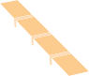

zintek® laminate

structural beams

raw wood planking 24 mm, spacing of approx.

5 mm for ventilation

fir wood battens, min. h 50 mm

ventilation gap, min. h 50 mm

breathable waterproof

sheathing

insulation vapour barrier

fir wood plank

structural beams

34

**ROOF COVERING PACKAGE 1:** ROOF WITH EXPOSED BEAMS

zintek® laminate

fir wood battens,

breathable waterproof sheathing

insulation, 50 mm

insulation

(variable thickness)

vapour barrier



zintek® laminate

raw wood planking 24 mm, spacing of approx.

5 mm for ventilation

fir wood battens, min. h 50 mm

breathable waterproof sheathing insulation, 50mm

structural beams insulation

(variable thickness)

vapour barrier

false ceiling cladding

ventilation gap, min. h 50 mm

raw wood planking 24 mm, spacing of approx.

5 mm for ventilation

min. h 50 mm

structural beams

false ceiling cladding

35

**ROOF COVERING PACKAGE 2:** ROOF WITH COVERED BEAMS

zintek® laminate

raw wood planking 24 mm, spacing of approx.

5 mm for ventilation

ventilation gap, min. h 50 mm

raw wood planking 24 mm, spacing of approx. 5 mm for ventilation

fir wood battens, min. h 50 mm

breathable waterproof sheathing

insulation

vapour barrier

concrete cover slab

fir wood battens, min. h 50 mm

breathable waterproof sheathing

insulation vapour barrier

concrete cover slab

wooden retaining battens



zintek® laminate

36

**ROOF COVERING PACKAGE 3:** ROOF WITH CONCRETE CEILING

interlocking ridge with cladding in zintek®

clip bracket

perforated sheet metal

wooden structure for ridge

ventilation gap, min. h 50 mm

zintek® sheet metal

raw wood planking

24 mm, spacing of approx. 5 mm for ventilation

fr wood battens, min. h 50 mm

breathable waterproof sheathing

insulation

vapour barrier

fir wood plank

structural beams



37

**VENTILATED RIDGE:** TYPE 1

perforated sheet metal

wooden structure for ridge

clip bracket

interlocking ridge with cladding in zintek®

fir wood battens, min. h 50 mm

breathable waterproof sheathing

insulation

vapour barrier

Fir wood plank

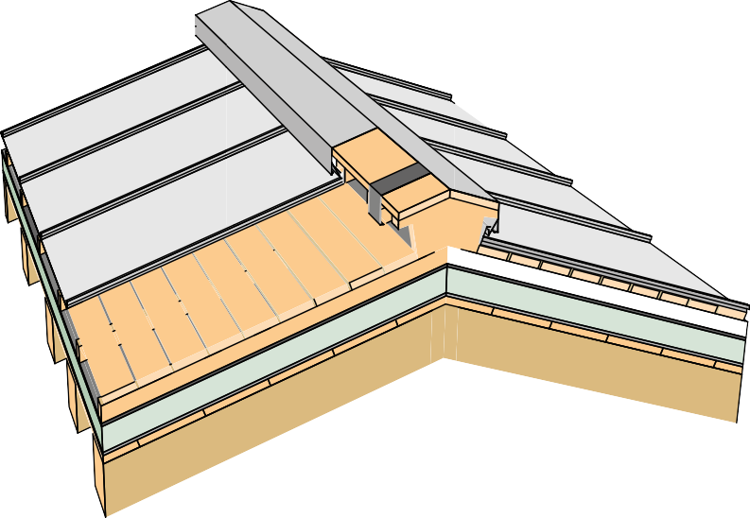

ventilation gap, min. h 50 mm

zintek® sheet metal

raw wood planking

24 mm, spacing of approx. 5 mm for ventilation

structural beams

38

**VENTILATED RIDGE:** TYPE 2 (FOR ROOF SLOPES > 35%)

eaves plank, 40 x 150 mm

zintek®  
standing seam

gutter

gutter

blades

eaves flashing

retaining batten

gutter support bracket

perforated aerat on plate

insulation

zintek® standing seam

zintek® eaves flashing

perforated aeration plate

gutter support bracket

zintek® gutter

vapour barrier

insulation breathable waterproof sheathing

fir wood battens, m n. h 50 mm

retaining batten

structural beams

fir wood or plasterboard plank ng

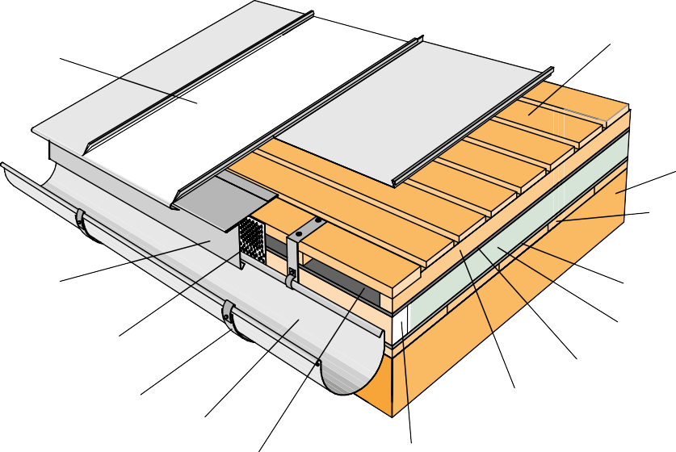

raw wood plank ng 24 mm, spacing of approx. 5 mm for ventilation

ventilation gap, m n. h 50 mm

raw wood plank ng 24 mm, spacing of approx.

5 mm for ventilation

f r wood batten and

vent lat on, h m n. 50 mm

breathable sheath ng

vapour barrier

f r wood or plasterboard plank ng

structural beams

39

**TINSMITHERY 1:** EXTERNAL GUTTER

fir wood strips and ventilation

vapour barrier

insulation

bituminous sheath or plastic sheaths

gutter of rectangular shape

wooden plank

bracket in stainless steel or galvanized iron gutter support

sealed flashing in zinc plated

perforated plate for aeration



24 mm rough wooden plank, spaced approx. 5 mm for ventilation

zintek® seamed sheet

zintek® gutter flashing

concrete overslab

40

**TINSMITHERY 2:** INTERNAL GUTTER

wooden plank

bracket in stainless steel or galvanized iron gutter support. Clip stops gutter stainless steel

gutter of rectangular shape

sealed flashing in zinc plated - 1 mm

concrete overslab

vapour barrier

insulation

fir wood strips and ventilation

5° slope



10/10 mm galvanised steel sealed flashing

zintek® plate concrete wall cladding

24 mm rough wooden plank, spaced approx. 5 mm for ventilation

zintek® seamed sheet

perforated plate for aeration

zintek® gutter flashing

bituminous sheath or plastic sheaths

41

**TINSMITHERY 3:** INTERNAL GUTTER WITH MASONRY





**FAÇADE SPECIFICS**

**TECHNICAL NOTES ZINTEK® FAÇADE COVERINGS**

**Thickness of the metal**

Thickness of the metal should ideally be 0.8 mm due to the increased rigidity of the surfaces on the metal sheet strip.

**Material**

When exposed, pre-weathered zintek® should be used. In this way it is possible to obtain a homogeneous surface appearance from the beginning of the task.

**Subdivision of the strip**

For reasons of shape, the individual surfaces of the walls should be divided symmetrically as far as possible.

In case of the unfavourable location of openings (such as windows, etc.), the remaining surface must be balanced out by using the thinner strips on the inside of the wall surface or on the corner of the building.

**Distance from the ground**

To avoid accumulation of dirt due to precipitation, which can divert water over pavements, roads or courtyard areas, the zintek® min coating should be placed at a distance of at least 15 cm from the ground.

**Measures against external influences**

In case of openings on facades, e.g. windows, substructures consisting of galvanised structural parts should be avoided and instead aluminium or stainless steel should be used.

44



**Means of fitting interlocking slat systems**

When fixing zintek® slats on aluminium substructures, use suitable rivets Ø 4.0 mm x the required length or screws for stainless steel sheet Ø 2.9 x 9.5 mm.

For wooden substructures, round head wood screws made of stainless steel Ø 3.0 x 25 mm are suitable. The quantity and distance of the fastening means must be calculated according to static calculations.

If necessary, in the case of extreme wind pressure loads, visible fastening systems may also be used.

**Additional stability for interlocking slat systems**

The lower slats are equipped with a three-layer wooden panel glued back to protect against dents in the areas of pathways or sports facilities, which is placed from the ground up to a height of approx. 1 m.

**Folding of interlocking slats**

For the slat terminals, folds with a panel width of ≥ 240 mm are required to ensure their stability.

[ref. to **Sviluppo in Architettura** manual]

45

**APPLICATION DESIGNS**



ventilation cavity between the insulation and planking

fir wood strips

tabs

wall structure

insulation

24 mm rough wooden plank, spaced approx. 5 mm for ventilation

zintek® cladding

wall structure

insulation

ventilation cavity between the insulation and planking

24 mm rough wooden plank, spaced approx. 5 mm for ventilation

zintek® cladding

48

**FAÇADE PACKAGE 1:** FAÇADE WITH VERTICAL SEAMING

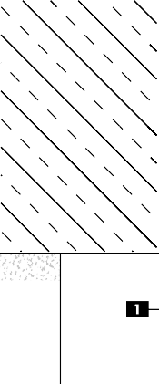

**Vertical section**

**Window upper frame detail**

**A. Seaming in zintek®**

1.

2.

Compressed tape seal

Perforated sheet metal in zintek®

Insulation

Sealed flashing

3.

4.

5.

Ventilation space

**Vertical section**

**Window sill detail**

49

**VERTICAL SECTION** – WINDOW DETAIL

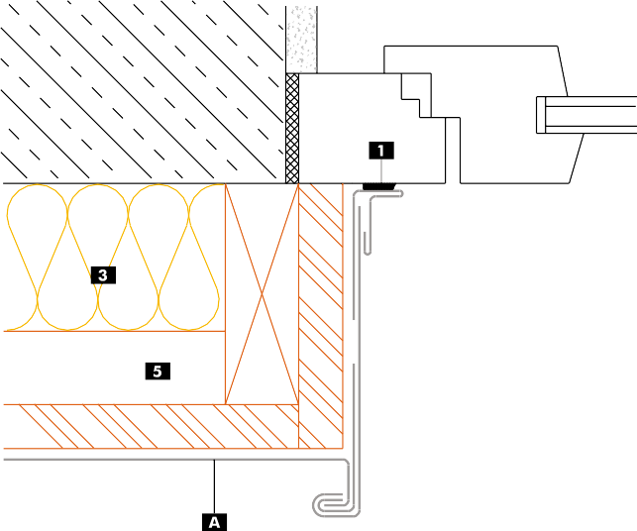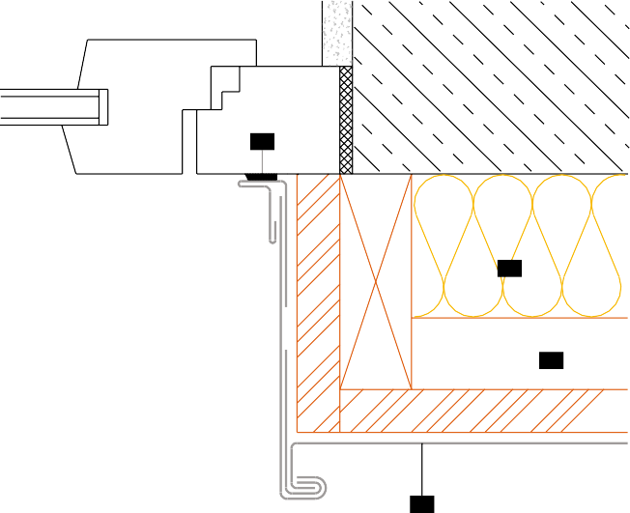



1

3

5

A

**A. Seaming in zintek®**

1.

3.

5.

Compressed tape seal Insulation

Ventilation space

50

**HORIZONTAL SECTION** – SIDE WINDOW DETAIL



vent lat on cav ty

wall structure

f r wood str ps

rough wood plank spaced

> 5 mm for vent lat on. T lted by about 30° to fac l tate the hook ng

of the plate by us ng tabs

nsulat on

tabs

z ntek® cladd ng

wall structure

nsulat on

vent lat on cav ty

rough wood plank spaced > 5 mm for vent lat on. T lted by about

30° to fac l tate the hook ng of the plate by us ng tabs

z ntek® cladd ng

51

**FAÇADE PACKAGE 2:** FAÇADE WITH HORIZONTAL SEAMING

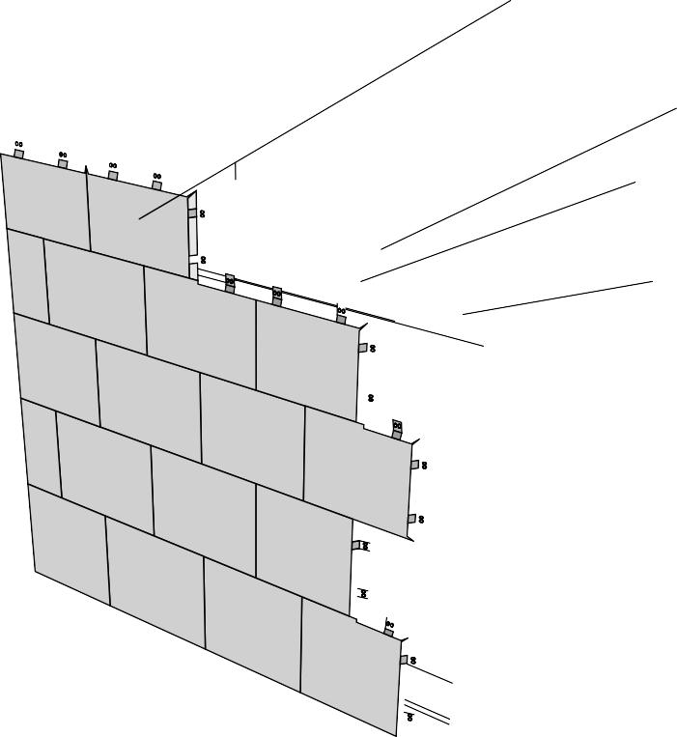

zintek® cladding

tabs

ventilation cavity between the insulation and planking

rough wood plank spaced

> 5 mm for ventilation

fir wood strips

insulation

wall structure

wall structure

insulation

ventilation cavity between the insulation and planking

rough wood plank spaced

> 5 mm for ventilation

zintek® cladding

52

**FAÇADE PACKAGE** WITH RECTANGULAR SHINGLES



zintek® cladding

fastening of shingles

rough wood plank spaced

> 5 mm for ventilation

ventilation cavity between the insulation and planking

fir wood strips

insulation

wall structure

wall structure

insulation

ventilation cavity between the insulation and planking

rough wood plank spaced

> 5 mm for ventilation

zintek® cladding

53

**FAÇADE PACKAGE** WITH DIAMOND-SHAPED SHINGLES

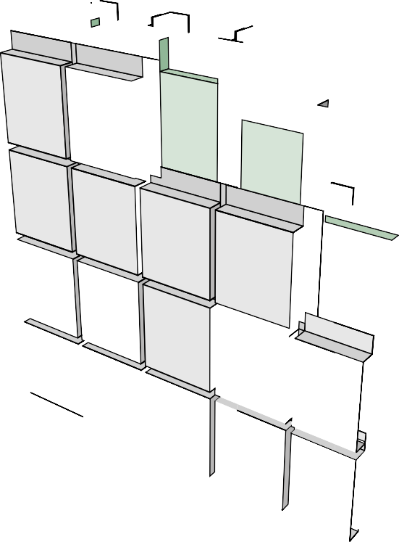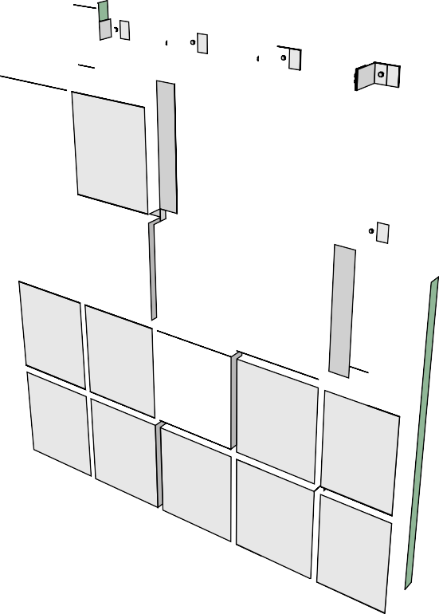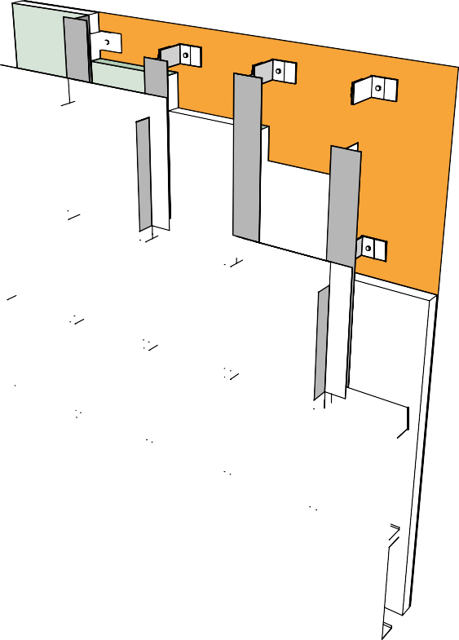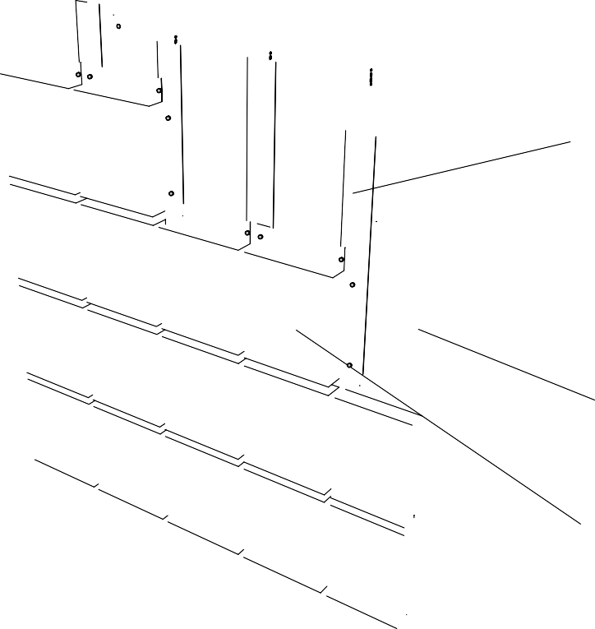

aluminium support bracket

aluminium T vertical upright for slats support and ventilation cavity

wall structure

insulation

zintek® cladding

aluminium vertical upright for slats support and ventilation cavity

aluminium support bracket

zintek® cladding

insulation

wall structure

54

**COFFERED SLATS COVERING**

AND ALUMINIUM SUBSTRUCTURE

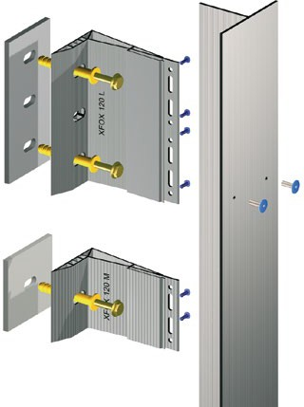

wall structure

aluminium support bracket

aluminium vertical upright for slats support and ventilation cavity

insulation

zintek® horizontal slats. 1 mm thickness

aluminium support bracket

aluminium vertical upright for slats support and ventilation cavity

55

**FAÇADE PACKAGE 3:** FAÇADE WITH HORIZONTAL SLATS AND ALUMINIUM SUBSTRUCTURE ALUMINIUM

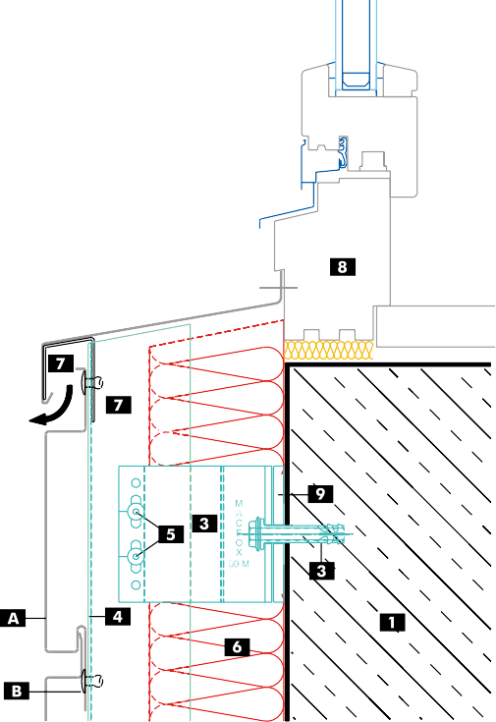

**Vertical section**

**Window upper frame detail**

1. **Horizontal slats in zintek®**
2. **Rivet**
3. **Flashing in zintek®**
4. **Perforated sheet metal in zintek®**

1.

2.

3.

4.

5.

6.

7.

8.

9.

Wall structure Support bracket Dowel

“L”-shaped profile Stainless steel screw Insulation Ventilation space Frame

ThermoStop

**Vertical section**

**Window sill detail**

56

**VERTICAL SECTION** – WINDOW DETAIL



1

9

9

3

10

10

7

7

2

2

5

4

4

5

8

8

C

BB

A

B

C

A

1. **Horizontal slats in zintek®**
2. **Rivet**
3. **Flashing in zintek®**

1.

2.

3.

4.

5.

6.

7.

8.

9.

Wall structure Support bracket Dowel

“L”-shaped profile Stainless steel screw Insulation Ventilation space Frame

ThermoStop

57

**HORIZONTAL SECTION** - SIDE WINDOW DETAIL

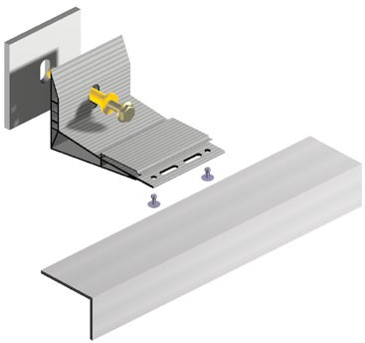

wall structure

aluminium support bracket

aluminium vertical upright for slats support

insulation

zintek® horizontal slats. 1 mm thickness

auminium support bracket

aluminium vertical upright for slats support

58

**FAÇADE PACKAGE 5:** FAÇADE WITH VERTICAL SLATS AND ALUMINIUM SUBSTRUCTURE





**Vertical section**

**Window upper frame detail**

7

6

2

5

3

1

8

7

1. **Vertical slats in zintek®**
2. **Rivet**
3. **Flashing in zintek®**
4. **Perforated sheet metal in zintek®**

D

7

1.

2.

3.

4.

5.

6.

7.

8.

9.

Wall structure Support bracket Dowel

“L”-shaped profile Stainless steel screw Insulation Ventilation space Frame

ThermoStop

8

7

7

1

6

5

2

4

3

**Vertical section**

**Window sill detail**

59

**VERTICAL SECTION** – WINDOW DETAIL

B

A

C

A

B

9

4

9



9

9

1

10

10

1

7

7

2

2

5

5

4

4

8

8

B

B

A

C

A

1. **Vertical slats in zintek®**
2. **Rivet**
3. **Flashing in zintek®**

1.

2.

3.

4.

5.

6.

7.

8.

9.

Wall structure Support bracket Dowel

“L”-shaped profile Stainless steel screw Insulation Ventilation space Window frame

ThermoStop

60

**HORIZONTAL SECTION** – SIDE WINDOW DETAIL

M A C F 0 X

90 M

3

C

3



**Vertical section**

**Gable detail**

1

7

7

6

5

2

3

1. **Vertical slats in zintek®**
2. **Rivet**
3. **Flashing in zintek®**

1.

2.

3.

4.

5.

6.

7.

9.

Wall structure Support bracket Dowel

“L”-shaped profile Stainless steel screw

Insulation

Ventilation space

ThermoStop

7

6

5

2

3

B

**Vertical section**

**Ground anchor detail**

7

1

C

7

6

5

2

B

3

**Vertical section**

**Façade frame detail**

61

**VERTICAL SECTION**

A

A

4

9

4

9

B

4

A

9



2 5

3

6

9

3

1

6

2

5

5

4

7

B

A

9

1

6

2

5

1. **Slats in zintek®**
2. **Rivet**

4

1.

2.

3.

4.

5.

6.

7.

9.

Wall structure Support bracket Dowel

“L”-shaped profile Stainless steel screw Insulation Ventilation space

ThermoStop

B

A

A

9

5

2

3

B

6

7

A

62

**HORIZONTAL SECTION** – DETAIL OF “EXTERNAL” TYPE CORNER

M A C F O X

90 M

M A C F O X

90 M

A

B

A

4

3

7

7

9



63

**Concept**

Zintek Srl

**Design and Layout**

Attiva S.p.A.

**Edition**

Settembre 2020

©2020 by Zintek Srl. Venezia





*ZINC-TITANIUM IN ARCHITECTURE*

**Zintek Srl**

via delle Industrie, 22

30175 Porto Marghera, Venezia - ITALY ph. 041 2901866

[zintek@zintek.it](mailto:zintek@zintek.it)

[**www.zintek.it**](http://www.zintek.it/)

EN

zintek.it